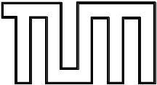

FAKÜLTÄT FÜR INFORMATIK
DER TECHNISCHEN UNIVERSITÄT MÜNCHEN

Bachelorarbeit in Informatik

Implementierung ausgewählter Komponenten des Hierarchical Temporal Memory Modells für die Epiphany Mehrkern-Prozessorarchitektur

Sravani Anne



FAKÜLTÄT FÜR INFORMATIK
DER TECHNISCHEN UNIVERSITÄT MÜNCHEN

Bachelorarbeit in Informatik
Implementierung ausgewählter Komponenten des Hierarchical Temporal Memory Modells für die Epiphany Mehrkern-Prozessorarchitektur
Implementation of Selected Components of the
Hierarchical Temporal Memory Model for the Epiphany Multi-Core Processor Architecture

Bearbeiterin: Sravani Anne
Aufgabensteller: Prof. Dr. –Ing. Habil. Alois Knoll
Betreuer: Priv. –Doz. Dr.Florian Röhrbein, Florian Walter, M. Sc
Abgabedatum: 30. September 2015

Ich versichere, dass ich diese Bachelorarbeit selbständig verfasst und nur die angegebenen Quellen und Hilfsmittel verwendet habe.
I confirm that this bachelor's thesis is my own work and I have documented all sources and material used.

Garching b. München, den ________________________
Ort, Datum Unterschrift

Abstract
HTM cortical learning algorithms demand a large computational platform due to the complexity in its hierarchy and functions performed. But the purpose of designing these algorithms is to improve the existing machine learning technology. The applications of machine learning algorithms vary from small mobile devices to space exploration labs. All these areas where machine learning is applied, perform heavy computations on large set of data. Therefore there is a need for cortical algorithms to perform efficiently under all circumstances despite the amount of resources allocated. If the algorithms cannot perform well under real time resources, the HTM cortical algorithms will fail to provide quality improvements to the machine learning technology. This thesis aims at implementing two HTM components-sparse distributed representations and learning rule on a parallel computing, embedded device called parallella. Parallella has 16 (also 64) epiphany cores, an ARM core. Inside epiphany, there is 512KB on-chip distributed shard memory. The epiphany cores with efficient parallel processing capability present an encouraging platform to implement and test cortical algorithms in real time. Introducing HTM cortical algorithms to epiphany core is the goal of this thesis. Firstly, the data structure to represent HTM is designed and then I proceeded on to implementing the HTM components. With the help of ARM core, the HTM components are implemented on epiphany core and tested one after the other to understand individual component’s efficiency.
Keywords: Hierarchical Temporal Memory, parallella, epiphany, Sparse Distributed Representation, Hebbian learning rules, learning, Neocortex, Spatial pooler.

Contents
Abstract III
List of Figures V
List of Tables VI
List of Formulae VII
1 Introduction 1
1.1 Introduction to HTM 2
1.1.1 Learning 2
1.1.2 Inference 3
1.1.3 Prediction 4
1.1.4 Behavior 5
1.2 Neocortex as HTM 5
1.3 Introduction to Spatial Pooler 7
1.3.1 Sparse Distributed Representation 8
1.3.2 Spatial Learning 9
2 HTM data model 10
2.1 Programming Model-Parallella 11
2.2 Structural Aspects of HTM 12
3 Implementation Details 16
3.1 Program Structure for Device side and Host side Applications 16
3.2 Implementation of Sparse Distributed Representation 18
3.2.1 Overlap 18
3.2.2 Inhibition 19
3.3 Implementation of Learning Rule 22
4 Results and Inference 25
4.1 Sparse Distributed Representation 25
4.1.1 Inference 26
4.2 Learning Rule 27
4.2.1 Inference 29
5 Future Work and Conclusion 32
5.1 Future of Learning Rule 32
5.2 Temporal Pooling and Prediction 32
References 34

List of Figures
Figure 1: Neuron Structure showing synapses 3
Figure 2: HTM region showing column structure 6
Figure 3: Proximal dendrite design 8
Figure 4: Parallella board(top view) 10
Figure 5: Parallella biard(bottom view) 10
Figure 6: Epiphany program build flow 12
Figure 7: HTM structure showing hierarchy of levels 13
Figure 8: Data Structure representing column matirx and proximal dendrites 14
Figure 9: Class diagram 15
Figure 10: Host program running on ARM core 16
Figure 11: Device program running on epiphany core 17
Figure 12: Overlap algorithm 19
Figure 13: Inhibition phase 20
Figure 14: Algorithm for random input map to columns 21
Figure 15: Implementation logic showing initialization 22
Figure 16: Step by step algorithm for sparse distributed representation 22
Figure 17: Learning algorithm 23
Figure 18: Sparse Distributed Representation Results 26
Figure 19: Input showing 32 active bits 27
Figure 20: Input showing 64 active bits 27
Figure 21: Learning rule results 29
Figure 22: Input frame showing 48 active bits 30
Figure 23: Input frame showing 192 active bits 30
Figure 24: Output of sparse distributed representation 31
Figure 25: Output of learning rule 31

List of Tables
Table 1: Memory locations used...............................................................................................23
Table 2: Sparse distributed representation results.....................................................................25
Table 3: Learning Rule results..................................................................................................28

List of Formulae
Formula 1: Sparse Factor..........................................................................................................25
Formula 2: Total Permanence Change......................................................................................28

- Introduction
Machine learning is a field of artificial intelligence that explores the construction and study of algorithms that can learn from inputs and make predictions on the future data. The goal of machine learning algorithm is to build a data model from the input history, identify the recurring patterns and predict the next input according to the inference made from the patterns [3]. Machine learning algorithms teach themselves to adapt their behavior when exposed to new data. Through learning, machines can perform complex tasks and these machines are more efficient than the manual programmed ones. With the growing data, the complexity of problems and the data also increases and machine learning reduces the burden of manual programming all that information into the computers of tomorrow. Learning processes include acquisition of new declarative knowledge, inferring conclusions from new knowledge, organizing the knowledge into general, effective representations, discovering new facts through observation and experimentation [17].
Brain is the most complex and mysterious organ in human body. It is responsible for thought, action, and memory. Brain is constantly learning from the environment to define, modify the actions performed, and habits displayed by humans. Brain is evolved up to a certain level in different family of animals. Mammalian brain, contained in humans is the highest form of evolution when compared to that of reptiles or any other animals that are part of biological system. The learning process is the most sophisticated thing in human brain and hence places humans at the top, in the race for intelligence. Gaining insights into the learning mechanisms of human brain and applying them to existing algorithms leads to more advanced machine learning algorithms [4].
Human brain consists of three parts: Cerebrum, Cerebellum and Medulla Oblongata [2]. Cerebrum is the largest part of human brain. It contains neocortex, and other centers for learning and memory. With the help of cerebellum, the cerebrum controls all the voluntary actions in human body. All the major functions like receiving inputs from human senses, storing the information and learning are performed in cerebrum. Inside cerebrum, neocortex is the most important part which enables cerebrum to perform all the above mentioned functions. The neocortex is made up of six layers, labeled from the outer in, I to VI. The neocortex is involved in higher functions such as sensory perception, spatial reasoning, conscious thought and language. The neocortex is the most complex of all the cerebral tissues and it plays a significant role in understanding the learning process inside human brain.
1.1 Introduction to HTM:
Hierarchical Temporal Memory (HTM) is one of the machine learning and neuro-computational model [11] that simulates the structure and function of neocortex inside a computer chip. It was developed by Jeff Hawkins and Dileep George of Numenta. HTM can be understood as any other Artificial Neural Network (ANN) since a given number of neurons form connections with each other [1]. But HTM is more complex than most of ANNs. HTM models neurons like any other ANN, in addition to this, these neurons are arranged in columns, then into layers and these layers are arranged into hierarchy. This hierarchy aspect of HTM deviates from common concept of ANNs and hence adds complexity to the problem [4].
HTM is a memory based system and it is different from the classic computer memory [1]. Simulating human memory on a computer is part of simulating neocortex. Classic computer memory has a flat organization. Programmer has control over how and where information is stored. But human memory is more restrictive and inherently time based. Information is always stored in a distributed fashion. Therefore while implementing neocortex as HTM, a user can only specify the size of hierarchy and what parameters to train the system on, but the HTM controls where and how the information is stored [1].
The above two paragraphs give the structural details for implementing HTM. There are four basic functions performed by HTM [1]:
- Learning
- Inference
- Prediction
- Behavior
1.1.1 Learning:
The crux of any learning algorithm is being able to identify patterns that often come together as input. In other words, the algorithm ‘learns’ the incoming input patterns and applies the inference derived from the patterns to make predictions. The learning algorithm can learn the weather conditions or delay patterns in flight schedule and thereby predict the expected flight time, taking into account the weather condition and flight delay timings in the past. Learning is the first step in the path of machine intelligence.
Learning is of two types- spatial learning and temporal learning [1]. Spatial learning is related to space- learning input bits that go together. Temporal learning is related to time-learning sequence of input patterns that go together over time.
In terms of HTM, learning is achieved by updating permanence values of potential synapses. Every neuron is connected to other neurons in a network with the help of synapses which branch out as shown in Fig. 1.But, among these synapses only a few connections are capable of exciting the neighboring neurons. Therefore, by allowing the neuron to make new connections enables HTM to learn and memorize new patterns in the input data.
Neuron Structure showing synapses
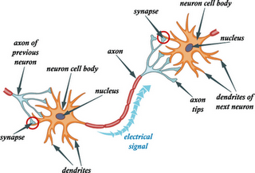Fig.1(source: internet)
Learning phenomenon is considered to be “online” by default, which indicates that learning is a continuous process and it happens continuously for each new input. Learning is then followed by inference and prediction phase. Although in some cases, inference happens simultaneously during the learning. Inference becomes accurate with more and more learning through input patterns.
1.1.2 Inference:
Successfully matching the new inputs to previously stored (learned) sequences is the essence of inference phase. An accurate inference must withstand noisy data and noisy input patterns. For example, considering the flight delay example mentioned previously, the inference about the flight delay has to be made irrespective of the outliers in the readings of temperature in the weather. In other words, the inference must not depend on one input, but rather on group of inputs to avoid wrong inference due to inconsistency. For example, a person who can speak English in one accent is able to understand all other English accents to some extent. This is because even though certain words like ‘rage’ differ in the way they sound when uttered, human brain can comprehend and cope up with different accents. Clearly these accents are outlier to a standard input sound signals. When same word is uttered in different accents, it activates different set of neurons each time. But to understand these different variants of same word, HTM uses a method called sparse distributed representation of input. Sparse distributed representation is a binary representation of input bits where only a small percentage of columns are made active. Sparse distributed representation of input helps in obtaining accurate inference in two ways:
- The input bits are represented using the activation of minimum number of neurons; hence any outlier data will have minimal effect on sparse distributed representations. The sparse distributed representation of input signals is stabilized over series of inputs. The inputs which have slight difference in the active bits (outlier data) are mapped to the same sparse representation. Hence in this way, noise handling is achieved to pave way for accurate inference [1, 11].
- The input bits are not only represented using least number of active columns but also by using activation of columns at different areas. In this way even though one column fails to activate, the error can be minimized on overall scale and the cortical algorithms are designed in such a way to proceed further if significant match to the input is obtained [11].
1.1.3 Prediction:
Prediction is the central goal of machine learning and data analysis. Prediction logic is usually based on the history of previous inputs and is also the final phase of HTM. This dependency on history of data can be considered as one of properties of prediction. There are many other properties which help in understanding the process of prediction [1].
- Prediction works hand in hand with inference to develop robust machine learning algorithms.
- Like learning, prediction is continuous, wherever learning happens prediction can happen
- Predictions are context sensitive.
For the sake of brevity, only few of the important properties are mentioned here and for further reading, white paper on cortical learning algorithms from Numenta Inc, or any book on machine learning is recommended.
Talking in terms of flight example that is previously mentioned, the input is the numbers from temperature sensors and rain gauge. The algorithm makes inference about the current weather condition based on data received. Therefore by using the obtained inference, delay patterns are observed. Based on the series of delay patterns, an overall aggregate prediction of expected flight delay time is made. Based on this understanding, in case there is missing temperature data or other sensor data, the prediction accuracy is not affected, but in turn it helps to fill in those missing data thereby improving the inference obtained in the later iterations. And as long as there is some sensor data, learning-inference-prediction sequence can be executed. Hence the prediction process is continuous. The flight delay patterns in the context of current inferred weather condition are considered which makes it context sensitive.
1.1.4 Behavior:
Behavior comes into picture when machine learning is applied to robotics. Behavior of robot is defined as the way it obtains the input from its surroundings by moving around to explore the environment. However in case of HTM, no particular behavior phase is modeled [1].
The structural and functional behavior of neocortex in human brain is very complex. Neocortex is made of several layers. Each layer is assigned with different functions inside human brain. Layers 3 and 4 are responsible for learning and prediction [1]. Only these layers are the point of interest for the research and are therefore implemented in HTM. The aim of HTM is not to imitate functioning of human brain but to interpret and apply its learning mechanisms in order to develop efficient machine learning algorithms [1, 4]. I believe this is the best shot at progress towards real machine learning and artificial intelligence.
In this thesis, sparse distributed representation and spatial learning components of HTM are implemented on parallella board which consists of an ARM core and epiphany multicore processors. The aim of this thesis is to implement these components and test the learning efficiency of small scale HTM networks on a single epiphany core. The results of sparse distributed representation are also presented. Chapter 2 describes the data model used to represent HTM on epiphany core. Chapter 3 gives the implementation details of the components. Chapter 4 presents results and inferences. Chapter 5 gives the scope for future of HTM on epiphany core.
1.2 Neocortex as HTM:
In this section, the simulation of biological behavior of neuron on epiphany core is discussed in detail. A cortical region of neocortex layer is modeled as 2D matrix of columns which in
turn contains neuron cells as shown in fig 2.
HTM region showing column structure:
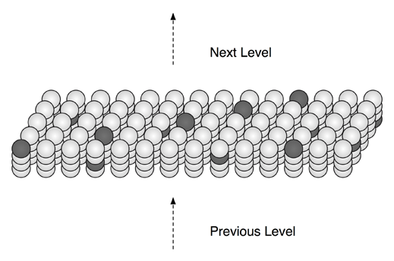Fig. 2(source: [1])
The cortical column (also called ‘minicolumn’) is a vertical organization of 80-100 neurons is the smallest level in the neocortex. These ‘minicolumns’ are further combined to form ‘macrocolumns’ and then later these ‘macrocolumns’ are combined to form ‘hypercolumn’ in a hierarchy [9]. In this thesis during implementation, only one level of columns is considered. These cortical columns are modeled the same way as they are formed in neocortex. Each column here is an array of neuron cells.
Neocortex in human brain is a dense network of neurons and by dense it means that it is highly inter-connected graph of nodes. Each neuron is connected to many other neurons through synapses [1, 5, 7]. Synapse is an electric impulse which is propagated when neuron is close enough to other neurons.Synapse when received by neighboring neurons trigger the activity inside cell and hence these synapses are responsible for making the neuron active or inactive. The dendrites of neuron are responsible for funneling synaptic potentials [6, 7]. The dendrites form synapses with other neurons to help in learning as shown in Fig 1.
There are two types of dendrites-proximal and distal dendrites. The proximal dendrite receives the feed-forward input and spatial learning is associated with these proximal dendrites and their synpases. The proximal dendrite synapses of neuron are modeled using two concepts called the potential synapses and permanence values. During implementation these concepts are designed as “dendrite_prox” and “permanence”. “dendrite_prox” is an array which represents all the axons that pass close to a dendrite segment which form the potential synapses. Permanence is a scalar float value assigned to each cell in “dendrite_prox” array. The permanence value of a dendrite_prox cell represents the amount of closeness between the dendrite and axon segment [1]. These values are between 0 and 1 and after certain threshold permanence, the potential synapse is considered connected synapse or simply synapse [1].
Human memory works sequentially and hierarchically [8]. A stimulus in brain is encoded and represented by activation and deactivation of many neurons. A pattern of activated and deactivated neurons is associated with each input (stimuli from external environment). This behavior is modeled using a variable called ‘state’ in each neuron node defined. The variable is assigned two values – value 1, if the neuron is active for the particular input and value 0, if the neuron is deactivated [1].
Human brain remembers these sequences of patterns. Remembrance here does not mean that neocortex stores these patterns explicitly like computer’s flat memory; it means that when neocortex sees the same pattern again, it can predict the next data in the incoming sequence [1, 8]. These patterns are combined in a hierarchy at different levels to obtain higher level patterns and complex predictions [1]. Prediction is happening continually [1, 8] – humans always try to predict in every situation, like who will walk through the door, what, a person says next. Therefore only by prediction, human brain can define the action to be performed. To cite an example, consider a person is touching a hot plate, the stimulus is sent to brain as input then the brain predicts the future danger of skin burn and sends a response to remove the hand from the plate.
1.3 Introduction to Spatial Pooler:
The term “Spatial pooler” means that, patterns which are spatially similar are pooled together [1]. Spatial pooler works on proximal dendrites at column level to learn connections between input bits and columns [10]. The proximal dendrites are those set of dendrites that are common to every cell in a column. Therefore for simplicity in the implementation, these proximal dendrites are considered as a property of column class even though they are a property of individual neurons as shown in fig. 3. The input to spatial pooler is a 2D array of binary 0’s and 1’s which may represent the information from sensors or information from human stimuli. In case the input is a set of electric potentials communicated from various devices in analog representation, these potentials can be converted to binary form using a threshold.

Proximal dendrite design
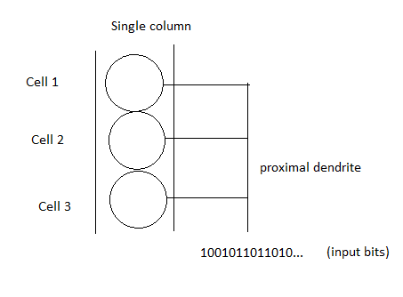Fig. 3
There are two phases in spatial pooler
- Sparse distributed representation
- Spatial Learning
1.3.1 Sparse Distributed Representation:
When feed forward input is received, it causes activation and deactivation of many columns. These input bits overlap with the proximal dendrites of many columns. The snapshot of these columns at any moment is defined as a spatial pattern. Since the neuron network is very dense, one input bit causes activation of many number of columns due to propagation. Those many number of active columns increases computational complexity. Therefore, we use sparse distributed representation of input bits. Using this representation does not cause any loss of information in input bits [1], but instead provides additional advantages that are mentioned under section 1.1.2 in this thesis.
According to recent research in neuroscience, it has been discovered that the brain also uses Sparse Distributed Representations (SDR) [11] unlike computer memory which uses ‘dense’ 32 bits encoding for input data. Jeff Hawkins, founder of numenta, has done extensive research in modeling these input data streams using SDRs. The work is partly mentioned in the white paper on cortical learning algorithms and this sparse distributed representation is used to train HTM. In this thesis, the sparse representation is implemented to obtain sparse set of active columns which are later used by learning algorithm.
1.3.2 Spatial Learning:
Spatial learning looks for combinations of input bits that occur often together which are called as spatial patterns [1]. These spatial patterns may be combined at higher levels to form more complex patterns. The region which is a 2D matrix of columns has limited learning capability. The amount of learning increases with the memory allocated to the region. More complex patterns are learnt if more memory is allocated. Spatial learning involves establishing connections or synapses between the cells of same region. Synapses are forming and breaking constantly during learning. The permanence value is used to indicate how close the connection is. When a connection is reinforced, its permanence is increased, otherwise the permanence is decreased. Therefore, after proximal dendrites forms synapses with feed-forward input, a sparse set of active columns determine which synapse’s permanence value must be increased and which ones must be decreased. This learning mechanism is similar to that of Hebbian rules.
Hebbian Learning rules:
In 1949, D.O. Hebb, published a description of simple set of rules for learning. He pointed out that given a connected network; the learning happening inside the nodes of network depends on the weights of connections between the nodes. According to him, the simultaneous excitation of two neurons results in the strengthening of connection between them [13]. He proved this point by showing the example where dog is trained every day to hear the bell and then receive the food. On a particular day, the bell rang but the food wasn’t served, but the dog’s mouth started to salivate. The permanence values connecting the neurons that get activated when bell rang and neurons that get activated when food is served have become so strong during the previous learning phase, that activation of one group of columns forced the activation of another group. Therefore as soon as the bell rang the dog expected to receive food and hence its mouth started salivating as a reaction.
In the implementation of HTM learning rules, these proven learning principles are followed, paving way for efficient learning. Finally, all the functions performed by the spatial pooler can be summarized as follows:
- Activates a set of columns based on given input.
- Determine how many valid synapses are connected to active bits.
- Column with highest number of activations in the past inhibits the others.
- Gives sparse representation of active columns.
- Update the permanence values and boost parameters.

2. HTM Data Model
All the selected HTM components are implemented on a single core in epiphany processor located on parallella board which is given in Fig 4 and Fig. 5.
Parallella board (top view)
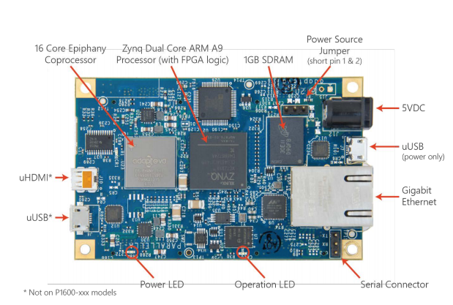Fig 4.(source:[14])
Parallella board (bottom view)
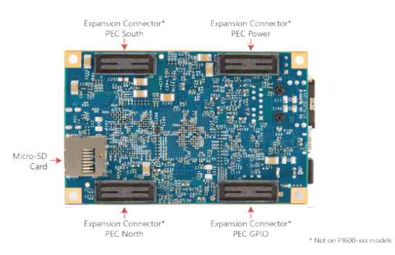Fig 5.(source:[14])
Parallella is a programmable platform which is open source based, efficient and high performance computer. It has two processors: an FPGA dual core arm processor located to the right in the center (fig 4) and a 16 core epiphany coprocessor located to the left in the center(fig 4), a power supply to the right which is connected to 2000mA rated 5V DC power supply(fig 4), a 10/100/1000 Ethernet(fig 4), a USB 2.0 host port on the left which connects to peripheral devices(fig 4), a micro SD card port towards left (fig 5) which serves as main external storage medium for the board. When parallella is booted for the first time the boot source files are placed in this SD card. A HDMI port to the left which can be connected to external display devices (fig 4). Apart from these main components there are different LEDs connected to the epiphany and arm processor to indicate the current state of these processors.
The two processors, ARM and epiphany are connected via shared buffer. All the communications between these processors happen via this shared buffer. The arm core is the main processor on parallella board. It belongs to a class of processors called ‘Zynq’ which combines the ARM cortex technology with Xilinx programmable logic [14]. In other words, ‘Zynq’ is a general purpose processor that is C/C++ programmable. The epiphany 16 core chips consist of an array of RISC processors which are again programmable in C/C++ or OpenCL. This makes epiphany core an easy access to all programmers irrespective of the level of expertise. It consists of a 2D array of processing cores connected by low latency mesh network-on-chip [15]. With the help of 16 core epiphany processor, parallella board provides wide platform for developing distributed applications and achieve high performance through parallel processing.
2.1 Programming Model - Parallella:
There are two programs that are usually written to parallella board. The first program is called the host program which runs on the ARM core. It is written in C or C++ and one of the functions of host application is to load srec file onto the epiphany core. Another program is written in C which defines the function to be performed on the epiphany core called the device application. This terminology device application for epiphany and host application for ARM application is documented in the sample examples shared by the parallella community. Therefore for the sake of uniformity in this thesis, same notation is followed. Both the applications are run using a special build file. A part of build file generates executable for the ARM core and the epiphany core called elf files. After the executable .elf is generated, the .elf file has to be converted to suitable file format in order to run on epiphany core. The series of steps performed while building the application are defined in next paragraph.
One of the file formats that are loadable on epiphany is .srec (also known as S-record) format [15]. A normal epiphany source file is compiled using a special compiler called e-gcc which includes linkers to the epiphany architecture set which generates an .elf file similar to that of .exe file. Using this elf file, the srec can be generated by executing the command ‘e-objcopy’. Prior to loading this srec file on to epiphany core, a core has to be selected which are row and column addressable. The e-loader takes the srec file and the selected coreid and loads it on to the core for execution. Epiphany processor supports two floating point operations on each clock cycle. The compilation process for the epiphany core is summarized in Fig. 6.
Epiphany program build flow
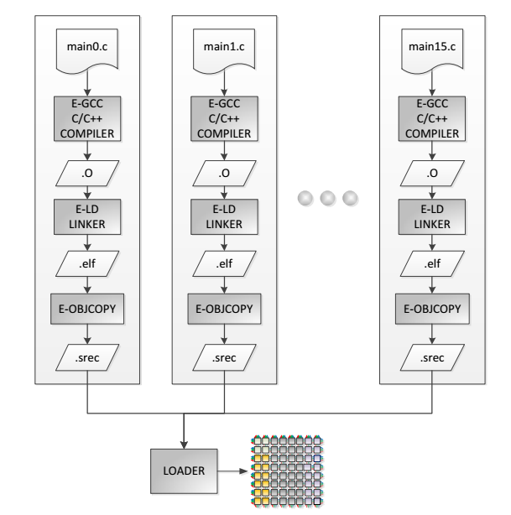 Fig. 6 (source: [16])
2.2 Structural Aspects of HTM:
After getting familiarized with the environment, I proceeded onto building data model for HTM. In the data model all the structural aspects of HTM are to be modeled. A successful data model represents the following structural aspects of HTM:
- HTM is a hierarchy of regions connected both forwards and backwards as shown in Fig 7. In other words, the regions are connected in the hierarchy which suggests that structure is an n-ary tree. But the data flow in the hierarchy not only flows from lower levels to higher levels as feed forward input but also backwards in the form of feedback input. Additionally, within a level, each region communicates and this is called lateral communication and hence data flow happens laterally, as shown in Fig. 7. The arrows represent the data flow. The above mentioned property cannot be modeled with graph data structure. Hence HTM can be considered as a graph of regions where each region is a node on the network. However, a single working region produces significant results in spatial learning and many machine learning applications today only use single region. The results shown in this thesis are tested with single working region.
HTM structure showing hierarchy of levels
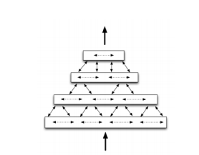Fig. 7 (source: [1])
- Looking deeper into a single region, each region contains separate hierarchy in itself. A region is a 2D array of columns where every column is a vertical 1D array of neuron cells as explained in the first chapter and shown in Fig 2. Therefore separate classes for column and region are to be defined and inside the region class a two dimensional array of columns class instance is initialized. In case of C language, structure can be defined for region and column instance. The implementation is done in C. Hence structures are used, instead of classes.
- Is there a requirement of a separate class for neuron cells too? The neocortex contains millions and millions of neurons [1] and lot of connections between them being modeled as dendrites. But a single epiphany core contains limited internal memory. Hence assigning class instances for each of those nerve cells can result in wastage of space and redundancy of data. After conducting thorough study in functioning of nerve cells, it has been identified that the properties of cell body doesn’t contribute to learning process, but only the dendrites and neuron state variable contributes. Hence instead of defining class for each neuron to model cell body parameters along with dendrites, only the neuron state variable and dendrites can be defined and modeled in column class, eliminating the need to define class instance for each neuron and thereby reducing the usage of memory.
- Each nerve cell has one proximal dendrite segment and a dozen or two distal dendrite segments as mentioned in [1]. Each of these segments may contain three or four branches of dendrites. It has already been established that the proximal dendrite is a property of column in [1]. Hence proximal dendrite segment is a 1D array of float values inside column class. The float values are the permanence values which indicate how many connected synapses are formed from the potential synapses.
- Distal dendrite segments are distinctive to the nerve cell. Hence for each cell in the column, a 1D matrix of distal dendrites is attached. Altogether, distal dendrite segment is a 2D array of matrix whose rows are defined by the number of cells in the column and columns are defined by the number of distal dendrites the cell has. For the sake of simplicity during implementation, a safe assumption that each cell contains single distal dendrite segment can be made without having to lose any modeled properties. Additionally, the number of distal dendrites for each cell can be same.
Based on these properties of HTM and assumptions mentioned here, a data structure for single region that is modified for implementing on smaller platform like epiphany single core, with its proximal dendrites is presented here in fig. 8.
Data Structure representing column matrix and proximal dendrites
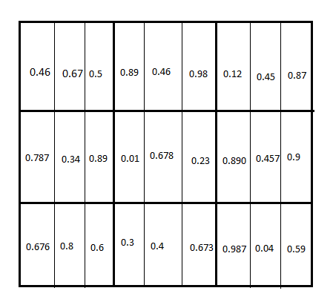Fig. 8
Each dark lined cell inside the matrix is a column and inside each cell it contains 1D array of proximal dendrites. The float values inside each proximal dendrite are random and they represent permanence values. The permanence value is defined as the amount of connectedness between the columns and input bits. Here fig. 8 shows a region of 3x3 columns with a set of 3 proximal dendrites assigned to each column cell and a random float value assigned to each dendrite. The data structure can be extended in similar way to model distal dendrites when temporal learning needs to be implemented.
Class diagram
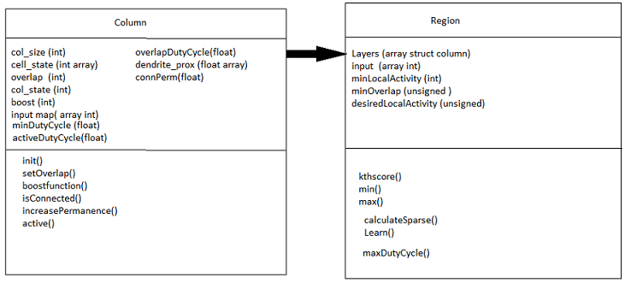Fig. 9
A class diagram (fig. 9) is constructed by carefully identifying the properties of column and properties of a region. The operations performed on the column and the operations performed on the region are separated and defined inside the two classes: column and region. Inside the class diagram each class is indicated by a rectangular box and the box is divided into 3 sub blocks. The first block inside a rectangular box displays the name of the class. The second block inside a rectangular box displays the properties that are specific to the class. The third block displays the functions performed by the class. The arrow connecting both the classes shows the relationship between the classes. The column class is instantiated inside region class.
In the implementation, since there is only one functional region. The functions performed by the region during the implementation of HTM components are written directly in the device program without separating them as functions, but when the classes are extended later to implement temporal pooling, the function modules need to be separately written. The explanation of different properties considered and the function performed by both the classes are mentioned in chapter 3 in detail. Fig. 9 represents the class diagram that is considered for the implementation of selected modules and fig. 8 represents the underlying data structure of HTM implemented on epiphany.

- Implementation details
This chapter describes the algorithms and programming approaches followed during implementation of sparse distributed representation and learning components of HTM.
All the components are written in C language. A separate header file is defined for column called ‘columnc.h’ where a structure is defined and all the function definitions of the operations performed on the column are written. The device program ‘e_htm.c’ that runs on epiphany contains the structure of region and operations performed on the region are written directly. The host application 'htm.c' runs on ARM core and loads the device application to run on epiphany core. For the sake of communication different shared buffers for different shared variables are required in the program.
3.1 Program Structure for Device side and Host side applications:
The host application ‘htm.c’ is written on ARM core which performs the following steps to prepare an epiphany program and load it on one of the cores.
Host Program running on ARM core:
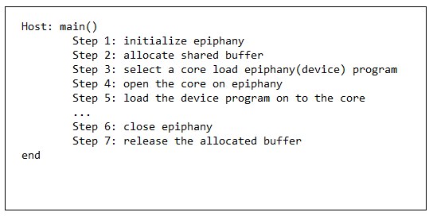 Fig. 10
Between step 5 and 6 the functions reading of and writing to the shared buffer connecting the cores is done.
The device application is loaded on to the epiphany core and the core HTM functions are performed.
Device program running on epiphany core:
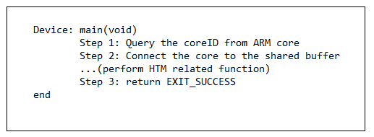 Fig. 11
The device application and host application are two different programs running on separate cores but working on the same input passed by the user to ARM. Therefore there is a need to synchronize the host and device application. The synchronization strategy chosen here for implementation is through understanding program states. A ‘mutex’ variable is used to lock on the shared resources during write operation.
The program requires definition of 4 states. They are:
OUTPUT_WAIT
OUTPUT_READY
INPUT_READY
INPUT_WAIT
A shared memory location with address 0x4000 is used to update the current state of both the programs. In this way host program can communicate with device program and vice- versa to know the current status of the running program. First the host application has to provide input which is assumed to be data from sensors or biological stimuli. Therefore host application updates the current state as INPUT_WAIT to inform the device program that it has to wait until the input is ready, it then locks on the shared buffer which is shared by epiphany to read the input. Once the input is written completely to the shared location the host application releases the lock on the shared buffer and the state is then updated to INPUT_READY. The shared memory location address chosen to write the input is 0x2000. In the meantime, the device application (program running on epiphany core) waits till the state is updated to INPUT_READY. This wait is implemented by continuously polling the memory location 0x4000. The device application now reads the updated state and changes it to OUTPUT_WAIT which tells the host program to wait for the output while device program is working. Once the selected HTM module is implemented on epiphany core, the device program locks on another shared buffer to write its output and releases the lock once the output is written completely, the device program releases the lock and updates the state as OUTPUT_READY ready while the host application polls 0x4000 for OUTPUT_READY. Once the state is updated, the host application reads out the output and displays it on the user screen. In this way, ARM core and epiphany core communication is achieved.
The above described synchronization methodology is chosen for implementation because it is highly reliable, secure and extensible. This strategy can be improved by improvising the polling method. When polling is done in a program for every second it increases the usage of processor resources and thereby increases the load on the processor. Due to this, the program execution load increases, therefore instead of polling every second, polling only at a particular interval of time is recommended. However when the program involves execution of small components like learning and sparse distribution, the polling strategies does not play a significant role in causing delays or improvisation of execution time. Another existing synchronization approach is to allow host program to sleep for a time interval. But this strategy is less efficient and extensible. If the sleep time interval is not properly calculated, the program may run into risk of losing synchronization and hence leads to unpredictable outputs.
  - Implementation of Sparse Distributed Representation
The sparse distributed representation is implemented in ‘e_htm.c’ under src subfolder in ‘sparseresults’folder. The sparse distributed representation is implemented in two steps:

- Compute the overlap with the current input for each column (also called overlap phase)
- Compute the winning columns after inhibition (also called inhibition phase)
3.2.1 Overlap
Inside the overlap function, the number of dendrites that form synapse with the input bits is counted for each column and accumulated under the variable ‘overlap’. Next the overlap scores of each column are boosted with respect to a threshold parameter ‘minOverlap’. All the values above the value ‘minOverlap’ are increased further by boosting and the values below are set to zero. In this way some columns that have only significant overlap with the current input are chosen to be active. The parameter ‘minOverlap’ is chosen according to the programmer’s choice. The parameter finally affects the number of columns that remain active. For example, consider a neuron with 1000 proximal dendrites. Every column forms some amount of overlap with the input connecting some of the proximal dendrites with the input bits. If the value ‘minOverlap’ is set to 900, very few columns will pass through this threshold as there will be very less number of columns that form such high overlap with the input. Therefore by controlling the value of ‘minOverlap’ programmer can control the number of active columns. Although the number active columns does not solely depend on ‘minOverlap’ and the permanence values parameters, but also on many other parameters that are mentioned further in this thesis. The combined effect of all those parameters is seen in the final output. The algorithm for overlap phase implemented is given below in fig. 12
Overlap Algorithm:
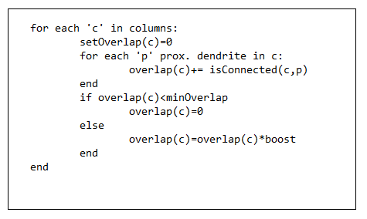Fig. 12
The function isConnected() returns 1 if the proximal dendrite’s permanence value is greater than the connected permanence (0.5) else value 0 is returned. The boost value is chosen according to the programmer’s choice.
3.2.2 Inhibition
Inhibition means to prohibit certain columns from winning. In order to calculate the number of winning columns, a parameter ‘desiredLocalActivity’ is chosen. ‘desiredLocalActivity’ controls the number of columns that win after a fixed number of columns are picked with the overlap phase. By modifying the parameter ‘desiredLocalActivity’ the number of active columns can be modified. If the ‘desiredLocalActivity’ is 50, all the columns whose overlap score is greater than 50 are chosen to become active finally and this phase marks the end of sparse distributed representation of the input bits. The algorithm implemented for inhibition phase is given below in fig. 13.

Inhibition phase:
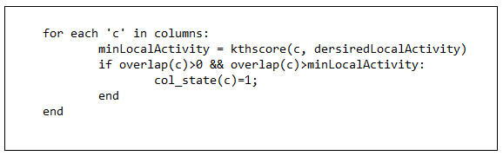
Fig. 13
The function kthscore() returns the local overlap score in the columns neighborhood. If the desiredLocalActivity value is 2, the kthscore function returns the second greatest overlap score in the neighborhood as minLocalActivity. Later, all the columns whose overlap is greater than this minLocalActivity become active to represent the input state in the sparse distributed representation.
Additional to the two main phases of sparse distributed representation, two more supporting methods are included in the implementation.
- Random mapping of columns to input bits
- Initialization of proximal dendrites with random permanence values after input mapping
While the overlap and inhibition phase ensure the sparseness of active columns, mapping input bits randomly to different columns ensures the activation of columns in distributed manner. The input bits are randomly mapped to particular column. The input to a region is 2D array of binary bits 1’s and 0’s. The necessity for the input to be a 2D array is linked with the initialization of permanence values which is explained in the next paragraph in detail. Each input bit is addressed with row and column. Inside column structure a variable ‘input_map’ is defined which tells what input bit is mapped to a given column. For the sake of generality, a random row and a random column are assigned to ‘input_map’ inside each column. The algorithm followed is given in Fig. 14.

Algorithm for random input map to columns
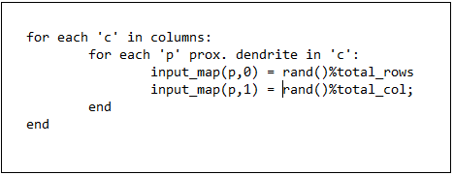 Fig. 14
Before calculating overlap phase, another phase called the initialization phase is included. A special initialization method is followed, instead of simply initializing all the permanence values to 0. In the latter case, there will be no winning columns. For initialization of permanence values two factors are mentioned in [1].
- The values chosen to be in small range around the connected permanence value.
- Each column has a natural center over input region. The column directly connected to the active input bit is ensured to be connected and the rest of the permanence values are biased towards this center.
The importance of considering these factors while initialization is explained in [1]. The neighborhood considered for the implementation is 4-neighbourhood. This neighborhood includes horizontal and vertical neighbors. There is another neighborhood called the 8-neighborhood. In this neighborhood, along with the straight neighbors the diagonal neighbors are also included. Since the second factor involves distance of input bits from the columns. The input is imagined as a separate, imaginary region overlapped above the HTM region. Once the column under the active input bit gets connected, the neighboring columns are closer to the input bit which is active and hence they get influenced due to propagation effect, but less than the column that is located directly below the active input bit. Hence the input is taken as a 2D array of binary values during implementation. The initialization algorithm used in the implementation is given below in Fig. 15. The threshold permanence value to declare connected synapse is 0.5 in the implementation. The range of values considered around this connected permanence is 0 to 1.

Implementation logic showing the initialization of proximal dendrite’s permanence value
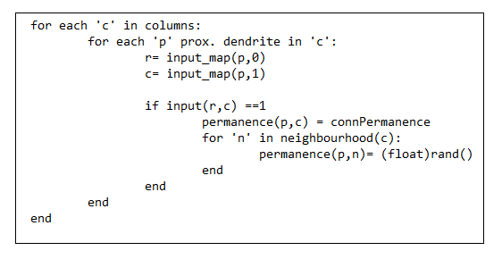 Fig. 15
The algorithms for implementing overlap and inhibition phase given in [1] are followed during implementation to complete the sparse distributed representation of input bits.
The total sparse distributed representation phases can be summarized in the following steps. These steps are followed in the implementation.
Step by step algorithm for sparse distributed representation
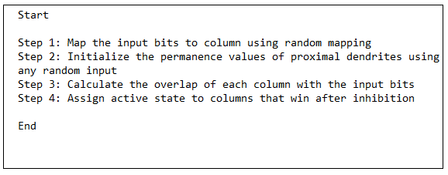 Fig. 16
  - Implementation of Learning Rule
The main learning rule involves changing permanence values which results in forming and breaking synapses between the columns. The implementation follows the learning rule given in [1]. The implementation related to this HTM component is in 'learnresults' folder. The learning results for one input frame are included in the next chapter.

Learning Algorithm:
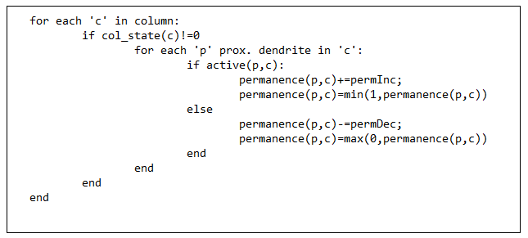 Fig. 17
The permanence values of those columns with col_state active are affected when learning happens. The permanence values are incremented or decremented depending on whether the dendrites are active or not. The function active returns the value 1 if the proximal dendrite was active else it returns 0. The permanence values must always be in the range 0 and 1.Hence all the overflowing values are wrapped so that the permanence values are maintained between 0 and 1
This learning rule can be extended to continuous input frames by using files on host application to store the state of proximal dendrite matrix at the end of each input frame. Then at the beginning of next input frame, the column can be initialized with the last updated state of proximal dendrite matrix. Using this approach the learning can be implemented to infinite number of input frames. Another approach is to load the input frames from host application using a ‘for’ loop. But this approach increases the complexity of host application and also restricts the number of input frames that can be loaded on to epiphany core.
The following table shows the memory address locations of the shared resources used during implementation.
Memory Locations used
Variable name | Definition of the variable | Shared location
Receivedinput | The shared buffer which sends the input to the device program | 0x2000
Sentoutput | The shared buffer which sends the output to the host. | 0x5000
Inpflag | The mutex variable defined to lock on the input buffer | 0x7000
Outflag | The mutex variable defined to lock on the output buffer | 0x6000
State | The variable used to communicate the status of the running program | 0x4000
Table : 1

- Results and Inference
There are two components implemented in this thesis and the end results of both the components and the screenshots of inputs considered for producing the results are shown and explained in detail in this chapter.
  - Sparse Distributed Representation
The program is tested to show the number of winning columns given a number of active input bits. The difference between the number of winning columns and number of active input bits is defined as sparse factor. This sparse factor is a metric to measure the number of columns that are saved in the process of representing the input without loss of information. The number of active input bits is increased in the powers of 2 and the corresponding sparse factors are calculated.
Sparse factor = active input bits-winning columns (1)
The following table shows the number of winning columns and sparse factor for the given inputs.
Sparse Distributed Representation Results:
Number of active input bits | Number of winning columns | Sparse factor
0 | 0 | 0
8 | 1 | 7
16 | 1 | 15
32 | 7 | 25
64 | 22 | 42
128 | 100 | 28
Table: 2
The sparse factor values for corresponding input bits are plotted on a graph. Fig. 18 shows this graph.

Sparse Distributed Representation Results
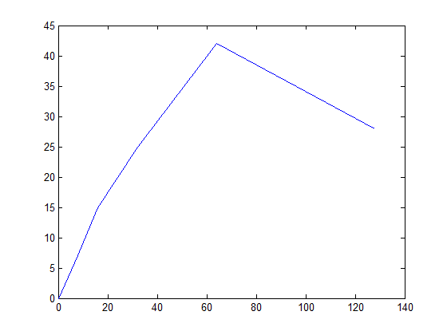 Fig. 18
4.1.1 Inference
An initial validation test for 0 active input bits is done, which resulted in the activation of 0 columns. When the active input bits are 8, the mapping indicates that 8 columns need to be activated. But due to sparse distributed representation only 1 column is needed to represent the input which results in minimum activation of columns. The sparse distributed representation is stable in case of sparse active input bits. In the case where there are 8 active input bits and 16 active bits the number of active columns did not change. This proves the stability of sparse distributed representation where series of inputs can be mapped to same activation number of columns. When there is slight change in active input bits also, the new input can be mapped to same sparse representation. This helps in saving the number of computations required for each input which in turn saves energy. The graph in Fig. 18 indicates that the sparse factor is more when the active input bits are around the range 40 to 80. The maximum sparse factor was achieved when the number of active input bits is 64. When the active input bits become dense, though the sparse factor is less, the sparseness is maintained consistent. Number of input bits saved is positive and consistent in all the inputs tested. The conclusion is that the sparse distributed representation performance of input bits has scaled efficiently from smaller region which consists of 256 columns, to the regions with 20000 and more columns.
Some of the input frames that were used to produce test results are given below. The input is written from a file ‘inputhtm.txt’ and the following screenshots show the contents of the input file used:

Input showing 32 active bits
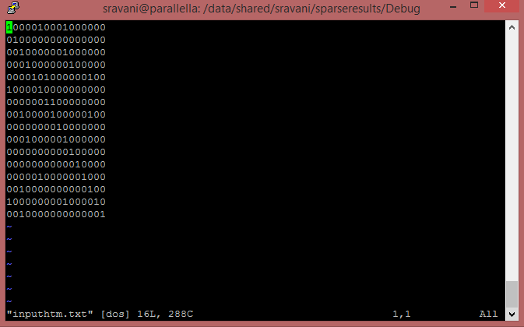 Fig. 19
Input showing 64 active bits
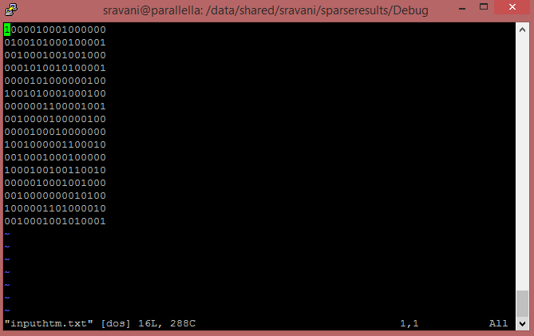 Fig. 20
4.2 Learning Rule
To test the learning algorithm efficiency, total permanence change is calculated for each input frame. The total permanence change factor is a cumulative count of total change in the permanence values. The principles of learning rules states that[1] when forming synapse with the input bits, if the proximal dendrite value is more than connected permanence value, its permanence value is increased by certain amount called the permanence increment defined in [1]. Same way if the dendrite’s permanence value is less than the connected permanence value its permanence value is decreased by certain amount called the permanence decrement, also defined in [1]. During implementation the permanence increment and decrement values are 0.1 and the connected permanence value is assumed to be 0.5. Total permanence change calculates the amount of total increments and decrements that occurred for a given input frame. This metric reflects the total amount of learning done with each input frame. The amount of learning is tested only for the initial input frames although this process can be extended to continuous input frames and calculate the same metric for ‘online learning’.
Total permanence change=total permanenceInc. + total permanenceDec. (2)
The following table shows the number of active input bits and the corresponding total permanence change
Learning Rule results:
Number of active input bits | Total permanence change
8 | 0.3
16 | 0.3
24 | 0.3
32 | 1.5
40 | 2.1
48 | 2.7
176 | 46.1999 (~ 46.2)
192 | 51.2999(~51.3)
208 | 58.7999 (~58.8)
Table: 3
The following is a graphical representation of total permanence change and number of active input bits
Learning rule results
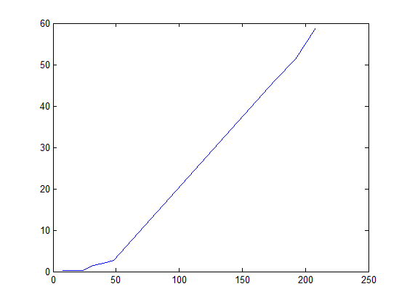 Fig. 21
4.2.1 Inference
The graph indicates that the learning remained almost constant for sparse input, where there is less number of active input bits. But the amount of learning increased continuously with the increase in the density if input bits which indicates that the dense input frames contain huge information that is learnt by the neural network in neocortex. By looking at total permanence change values, it can be concluded that the learning has also scaled successfully indicating positive results for implementing HTM on small storage devices like epiphany. The total permanence change remained always a multiple of 3 because the each column has 3 proximal dendrites in the implemented code and for each of the active column caused change in all of its proximal dendrites. Hence the total change is 3 times the number of active columns. The number of active columns can be calculated from the total permanence value also. The float values in the end instead of showing rounded values shows approximate values because most decimals have infinite binary representation. So when floating point arithmetic like 0.3 + 0.6 is done the result is actually represented as 0.899991 instead of 0.9. This means that the result 0.89991 can be safely rounded off to 0.9. Hence the same logic applies for the values represented in the table as well.
Some of the input frames used for producing the test results are given below. The same ‘inputhtm.txt’ file is used for loading the input values to the learning algorithm.
Input frame showing 48 active bits
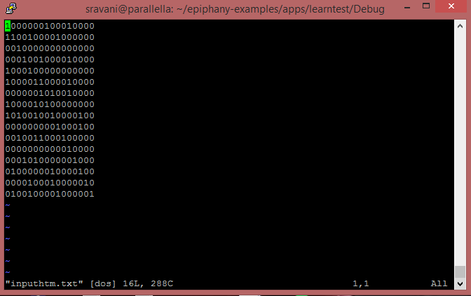
Fig. 22
Input frame showing 192 active bits
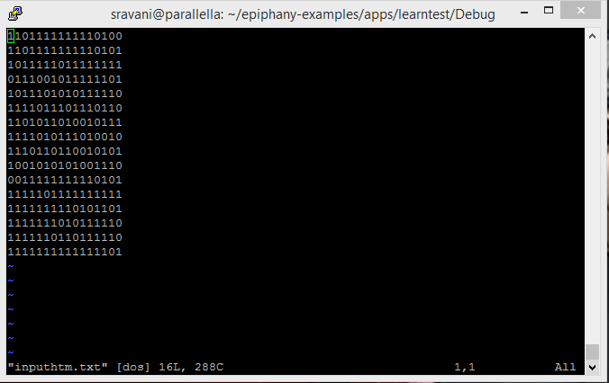
Fig. 23
The snap shot of the output screens for the sparse distributed representation and the learning principle are given below.
Output of sparse distributed representation:
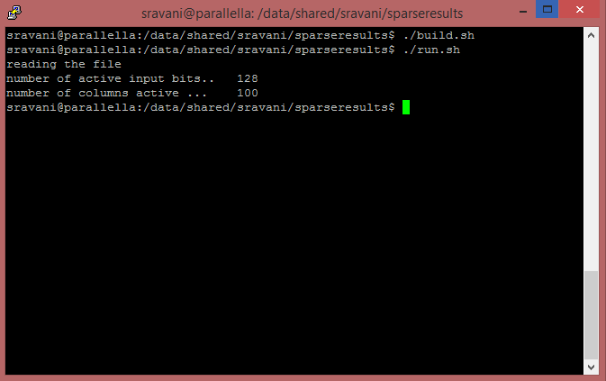Fig.24
Output of learning rule:
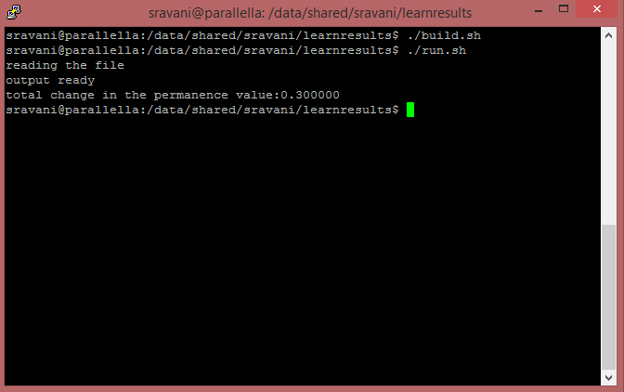
Fig. 25
- Future Work and Conclusion
The sparse distributed representation of input bits and a basic learning rule are implemented successfully and can be concluded that epiphany becomes an encouraging platform for implementing HTM components in future. All the components are implemented on single core, but to improve the performance and to accommodate larger matrices of columns, the underlying data structure has to be changed. The data structures for parallel implementation on all the cores are proposed in [10]. These components loop through the whole matrix of columns and apply the logic to every cell in the column, hence the data structure and implementation logic has to be optimized.
5.1 Future of Learning Rule
There are two processes proposed in [1] that support this basic learning rule to make learning more realistic and efficient.
- The learning rule can be extended to continuous input frames, and the difference in the change of permanence values between the input frames can determine the efficiency of prediction phase which follows next. One way to achieve this, as already mentioned is through using files. By storing the state of region in a file in the ARM core at the end of each input frame and by loading the state to epiphany core at the beginning of next input frame, this proposed continuity of input frames and state can be maintained. The file system is not accessible on epiphany core; therefore a file on epiphany cannot be created.
- There are two boosting mechanisms that help dendrite to form connections. If the column remains without significant overlap for a long time when compared to the neighborhood, its boost value is increased just to make the column compete with its neighbors for overlap with the input bits. If the connected synapse of a particular column does not result in the activation of columns in the final output then the permanence values of that column are increased to make the column active.
5.2 Temporal Pooling and Prediction
The true efficiency of learning algorithm is measured only if HTM is able to predict the next output. For each of the input the next predicted state must be calculated. Temporal pooling relates to time. While spatial pooling learns connections with input patterns and generates column states, the temporal pooler learns about how these columns states change over time. By understanding these sequences of states, HTM generates the next predictive state. The temporal pooler operates on distal dendrite segments, at the level of individual cells within columns. The output from the spatial pooler is passed on to temporal pooler as input to work on prediction. Hence temporal pooling plays an important role in prediction. The algorithms required for implementing spatial pooling are explained in detail in [1].

References

[1] Numenta, Hierarchical temporal memory including HTM cortical learning algorithms, Technical report, Version 0.2.1,2011.
[2] Ramachandran V.S., Encyclopedia of human behavior,2nd ed., vol 3, California: Academic Press,Elsevier Inc., 2012.
[3] P. Domingos, “A Few Useful Things to Know about Machine Learning”, Communications of the ACM, 55(10),October 2012.
[4] Numenta, The path to machine intelligence, Technical report,2014.
[5] Mohemmed, A.,Matsuda, S.,Schliebs, S., Dhoble, K., Kasabove, N.: “SPAN: Spike Pattern Association Neuron for Learning Spatio-Temporal Spike Patterns”, International Journal of Neural Systems, 22(4), pp 1-16, 2012.
[6] Stuart G and Sakmann B, “Active propagation of somatic action potentials into neocortical pyramidal cell dendrites”, Letters to Nature,367, pp 69-72,1994.
[7] Lodish H, Berk A, Kaiser, C. A, Krieger M, “Overview of Neuron Structure and Function” in Molecular Cell Biology, 4th ed., New york: W. H Freeman, 2000 ,ch 21,sec 21.1.
[8] Kurzweil R, How to create a mind, New york: Penguin Books Ltd, 2012, ch 3-5, pp 34- 108.
[9] Buxhoeveden DP, Casanova MF, “The minicolumn hypothesis in neuroscience”, Brain, 125, pp 935-951, 2002.
[10] Xi Zhou ad Yaoyao Luo, “Implementation of Hierarchical Temporal Memory on a Many-Core Architecture”, Ph. D dissertation, Halmstad University, 2013.
[11] Hawkins J, Sparse Distributed Representations, [Online]. Available: www.cortical.io/technology_representations.html.
[12] Pilly, P. K. and Grossberg S, “How do spatial learning and memory occur in the brain? Coordinated learning of entorhinal grid cells and hippocampal place cells”, Journal of Cognitive Neuroscience (in press), 2012.
[13] Broderick M, “Hebbian Learning Rules”, Technical Report, Doc. of Professional Studies,Pace University, New york, Dec. 12, 2002.
[14] Parallella, Parallella-1.x Reference Manual, Hardware reference manual, Version: 14.09.09.
[15] Adapteva(2008), “Epiphany Architecture Reference”. [online], Available: http://www.adapteva.com/docs/epiphany_arch_ref.pdf
[16] Adapteva (2008), “Epiphany SDK Reference”. [online], Available: http://www.adapteva.com/docs/epiphany_sdk_ref.pdf
[17] Michalski R.S., Carbonell J.G., Mitchell T. M., “An overview of Machine Learning” in Machine Learning: An Artificial Intelligence Approach, vol 1,california: Tioga publishing Co., 1983, ch 1, pp 3-16.

Gliederungsebene 2
Die vier Formatvorlagen „Ü1T“, „Ü2T“, „Ü3T“ und „Ü4T“ sind für die Gliederung des Hauptteils der Arbeit in insgesamt vier Ebenen gedacht und tauchen dementsprechend auch im Inhaltsverzeichnis der Arbeit auf. Der Textkörper selbst ist mit der Formatvorlage „Text“ auszuzeichnen (wichtig: nicht „Standard“ verwenden!).

Gliederungsebene 2
Abbildungen selbst erhalten die Formatvorlage „Abbildung“. Zugehörige Beschriftungen die Formatvorlage „Beschriftung“, die Quelle der Abbildung „Beschriftung_Quelle“.
dient als Beispiel für eine Abbildung.
Abbildung
Abbildung 1: Beispiel-Abbildung
Quelle: Eigene Darstellung
- Introduction

Gliederungsebene 2
Passendes Zitat zur Einleitung eines Abschnitts, welches nicht zum Textteil gehört.
(Quelle)

Gliederungsebene 3
Text Text Text Text Text Text Text Text Text Text Text Text Text Text Text Text Text Text Text Text Text Text Text Text Text Text Text Text Text Text Text Text Text Text Text Text Text Text Text Text Text Text Text Text Text Text Text Text Text Text Text Text Text Text Text Text. „normales Zitat im Textkörper” .
„mehrzeiliges langes eingerücktes Zitat …………………………………………… ………………………………………………………………………………………… ………………………………………………………………………………………… …………………………………………………………“ (Quelle).
Text Text Text Text
Text Text Text Text
- Text_Aufzählung;
- Text_Aufzählung;
- Text_Aufzählung.
Aufzählungen sollten in einem korrekten Satz eingebaut werden

Gliederungsebene 3
Text Text Text Text. Tabelle 1 dient als Beispiel für eine Tabelle. Die Formatvorlagen für die Beschriftungen sind analog zu den Abbildungen „Beschriftung“ und „Beschriftung_Quelle“.
Tabelle_Überschrift | Tabelle_Überschrift
Tabelle_Zelle | Tabelle_Zelle
Tabelle_Zelle | Tabelle_Zelle
Tabelle_Zelle | Tabelle_Zelle
Tabelle 1: Beispiel-Tabelle
Quelle: …
Text Text Text Text
Text Text Text Text
Überschrift im Textkörper
Text Text Text Text Text Text Text Text Text Text Text Text Text Text Text Text Text Text Text Text Text Text Text Text Text Text Text Text Text Text Text Text Text Text Text Text Text Text Text Text Text Text Text Text Text Text Text Text Text Text Text Text Text Text Text Text.
Als Beispiel für eine Formel dient Formel 1. Auch hier ist die Beschriftung und dessen Quelle analog zu den Abbildungen mit „Beschriftung“ und „Beschriftung_Quelle“ zu kennzeichnen.
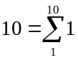
Formel 1: Beispiel-Formel
Quelle: eigene Berechnung
Text Text Text Text Text Text Text Text Text Text Text Text Text Text Text Text Text Text Text Text Text Text Text Text Text Text Text Text Text Text Text Text Text Text Text Text Text Text Text.
Überschrift im Textkörper
Text Text Text Text Text Text Text Text Text Text Text Text Text Text Text Text Text Text Text Text Text Text Text Text Text Text Text Text Text Text Text Text Text Text Text Text.
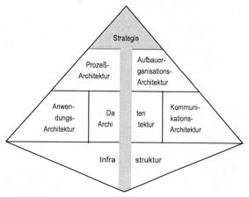
Abbildung 2: Integrierte Informationssystem-Architektur (ISA)
Quelle:

Reference
Krcmar, H. (1990). Bedeutung und Ziele von Informationssystem-Architekturen. Wirtschaftsinformatik, 32(5), 395-402.
Krcmar, H. (2005). Informationsmanagement (4 ed.). Berlin; Heidelberg; New York: Springer Verlag.

Anhang
- Anhang-Gliederungsebene 1
  - Anhang-Gliederungsebene 2
Lediglich die erste Gliederungsebene des Anhangs wird im Inhaltsverzeichnis berücksichtigt. Die Formatvorlagen für die Gliederung des Anhangs lauten „Ü1Anhang“ und „Ü2Anhang“.

Fußzeile
Fußzeile2

